TGA has created a new Natural Gas License Plate to benefit the TGA Scholarship Foundation’s Scholarship Program and needs your help to reach the required goal of 1,000 pre-orders. Why not show your support for Natural Gas and help students succeed. Visit www.tngas.org/license-plate for more information. | 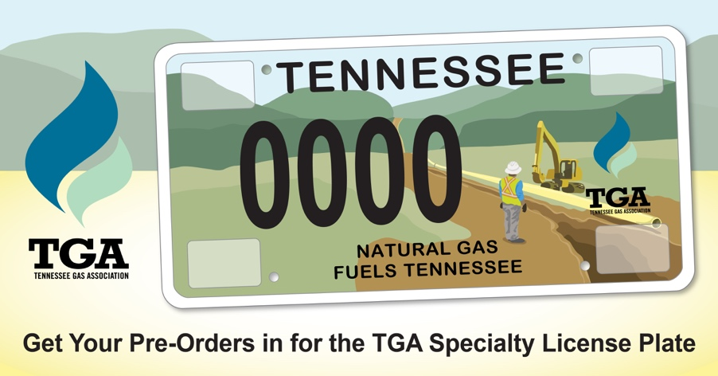
Show your support for Natural Gas and help students succeed by pre-ordering the new TGA specialty license plate! TGA has received approval for the plate and now needs 1,000 pre-order commitments before production can begin. Funds raised through the sale of the license plates go to the TGA Scholarship Foundation. Visit www.tngas.org/license-plate for more information. | 